# Machine learning assignment 1 Roll no - 12CS10046

1. 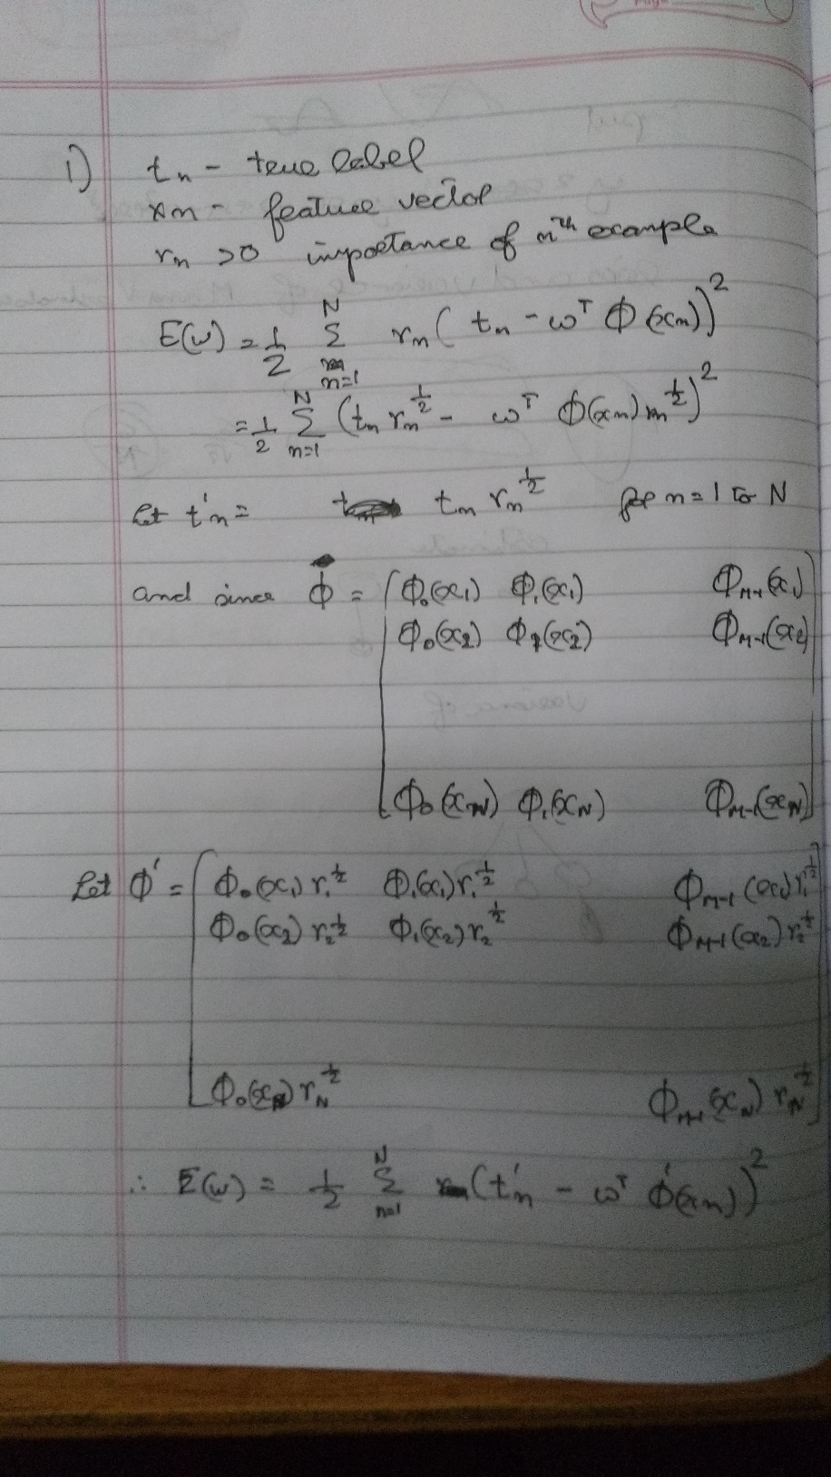  
     
   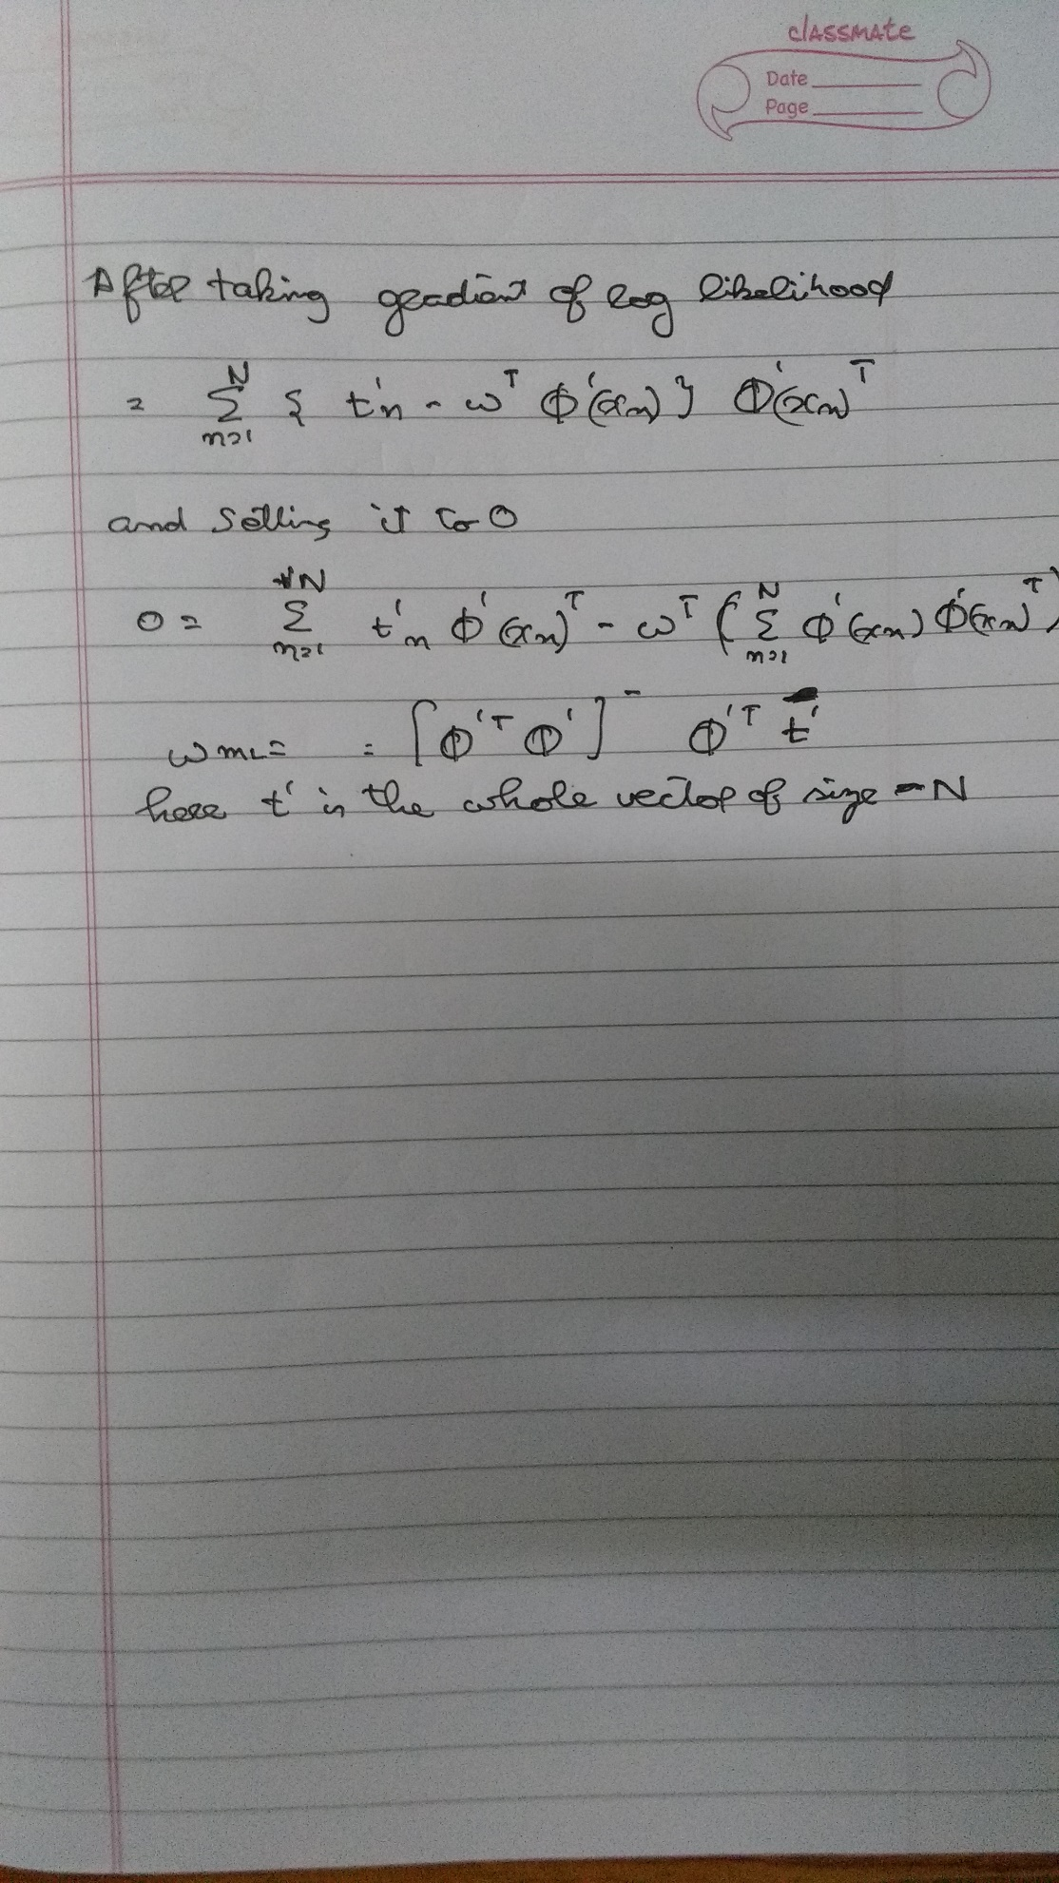

Instances: 506

Attributes: 14

att_1

att_2

att_3

att_4

att_5

att_6

att_7

att_8

att_9

att_10

att_11

att_12

att_13

class

Test mode:split 60.0% train, remainder test

For different values of λ

λ =

* 1. 0.00001

Linear Regression Model

class =

-0.1084 * att_1 +

0.0458 * att_2 +

2.7187 * att_4 +

-17.376 * att_5 +

3.8016 * att_6 +

-1.4927 * att_8 +

0.2996 * att_9 +

-0.0118 * att_10 +

-0.9465 * att_11 +

0.0093 * att_12 +

-0.5226 * att_13 +

36.3411

Time taken to build model: 0.04 second

=== Evaluation on test split ===

=== Summary ===

Correlation coefficient 0.8612

Mean absolute error 3.3689

Root mean squared error 4.5651

Relative absolute error 51.6839 %

Root relative squared error 50.8522 %

Total Number of Instances 202

* 1. 0.0001

Linear Regression Model

class =

-0.1084 * att_1 +

0.0458 * att_2 +

2.7187 * att_4 +

-17.376 * att_5 +

3.8016 * att_6 +

-1.4927 * att_8 +

0.2996 * att_9 +

-0.0118 * att_10 +

-0.9465 * att_11 +

0.0093 * att_12 +

-0.5226 * att_13 +

36.3411

Time taken to build model: 0.03 seconds

=== Evaluation on test split ===

=== Summary ===

Correlation coefficient 0.8612

Mean absolute error 3.3689

Root mean squared error 4.5651

Relative absolute error 51.6839 %

Root relative squared error 50.8522 %

Total Number of Instances 202

* 1. 0.001

Linear Regression Model

class =

-0.1084 * att_1 +

0.0458 * att_2 +

2.7187 * att_4 +

-17.3759 * att_5 +

3.8016 * att_6 +

-1.4927 * att_8 +

0.2996 * att_9 +

-0.0118 * att_10 +

-0.9465 * att_11 +

0.0093 * att_12 +

-0.5226 * att_13 +

36.3408

Time taken to build model: 0.03 seconds

=== Evaluation on test split ===

=== Summary ===

Correlation coefficient 0.8612

Mean absolute error 3.3689

Root mean squared error 4.5651

Relative absolute error 51.6838 %

Root relative squared error 50.8522 %

Total Number of Instances 202

* 1. 0.01

Linear Regression Model

class =

-0.1084 * att_1 +

0.0458 * att_2 +

2.7188 * att_4 +

-17.3743 * att_5 +

3.8017 * att_6 +

-1.4925 * att_8 +

0.2995 * att_9 +

-0.0118 * att_10 +

-0.9465 * att_11 +

0.0093 * att_12 +

-0.5225 * att_13 +

36.3376

Time taken to build model: 0.02 seconds

=== Evaluation on test split ===

=== Summary ===

Correlation coefficient 0.8612

Mean absolute error 3.3689

Root mean squared error 4.565

Relative absolute error 51.6831 %

Root relative squared error 50.8517 %

Total Number of Instances 202

* 1. 0.1

Linear Regression Model

class =

-0.1083 * att_1 +

0.0458 * att_2 +

2.7195 * att_4 +

-17.3593 * att_5 +

3.8029 * att_6 +

-1.4911 * att_8 +

0.2989 * att_9 +

-0.0117 * att_10 +

-0.9463 * att_11 +

0.0093 * att_12 +

-0.5224 * att_13 +

36.3057

Time taken to build model: 0.09 seconds

=== Evaluation on test split ===

=== Summary ===

Correlation coefficient 0.8612

Mean absolute error 3.3684

Root mean squared error 4.5646

Relative absolute error 51.6755 %

Root relative squared error 50.8468 %

Total Number of Instances 202

* 1. 1

Linear Regression Model

class =

-0.1074 * att_1 +

0.0453 * att_2 +

2.7262 * att_4 +

-17.2099 * att_5 +

3.8142 * att_6 +

-1.4767 * att_8 +

0.2928 * att_9 +

-0.0115 * att_10 +

-0.9439 * att_11 +

0.0093 * att_12 +

-0.5212 * att_13 +

35.9922

Time taken to build model: 0.02 seconds

=== Evaluation on test split ===

=== Summary ===

Correlation coefficient 0.8615

Mean absolute error 3.3635

Root mean squared error 4.5605

Relative absolute error 51.6015 %

Root relative squared error 50.8017 %

Total Number of Instances 202

* 1. 10

Linear Regression Model

class =

-0.0998 * att_1 +

0.0413 * att_2 +

2.7775 * att_4 +

-15.8401 * att_5 +

3.9043 * att_6 +

-1.3486 * att_8 +

0.2428 * att_9 +

-0.0094 * att_10 +

-0.9214 * att_11 +

0.0093 * att_12 +

-0.5098 * att_13 +

33.2887

Time taken to build model: 0.03 seconds

=== Evaluation on test split ===

=== Summary ===

Correlation coefficient 0.8634

Mean absolute error 3.3299

Root mean squared error 4.5403

Relative absolute error 51.0848 %

Root relative squared error 50.576 %

Total Number of Instances 202

* 1. 100

Linear Regression Model

class =

-0.075 * att_1 +

0.0272 * att_2 +

2.8313 * att_4 +

-9.2248 * att_5 +

3.9836 * att_6 +

-0.7395 * att_8 +

0.0822 * att_9 +

-0.0043 * att_10 +

-0.7827 * att_11 +

0.0086 * att_12 +

-0.4259 * att_13 +

22.9394

Time taken to build model: 0.04 seconds

=== Evaluation on test split ===

=== Summary ===

Correlation coefficient 0.86

Mean absolute error 3.4177

Root mean squared error 4.746

Relative absolute error 52.4325 %

Root relative squared error 52.8679 %

Total Number of Instances 202

* 1. 1000

Linear Regression Model

class =

-0.0546 * att_1 +

0.016 * att_2 +

-0.071 * att_3 +

1.7399 * att_4 +

-3.5029 * att_5 +

2.1139 * att_6 +

-0.0103 * att_7 +

-0.087 * att_8 +

-0.0028 * att_10 +

-0.4174 * att_11 +

0.0051 * att_12 +

-0.1924 * att_13 +

22.4032

Time taken to build model: 0.02 seconds

=== Evaluation on test split ===

=== Summary ===

Correlation coefficient 0.8086

Mean absolute error 4.5596

Root mean squared error 6.389

Relative absolute error 69.951 %

Root relative squared error 71.1692 %

Total Number of Instances 202

1. Done
2. 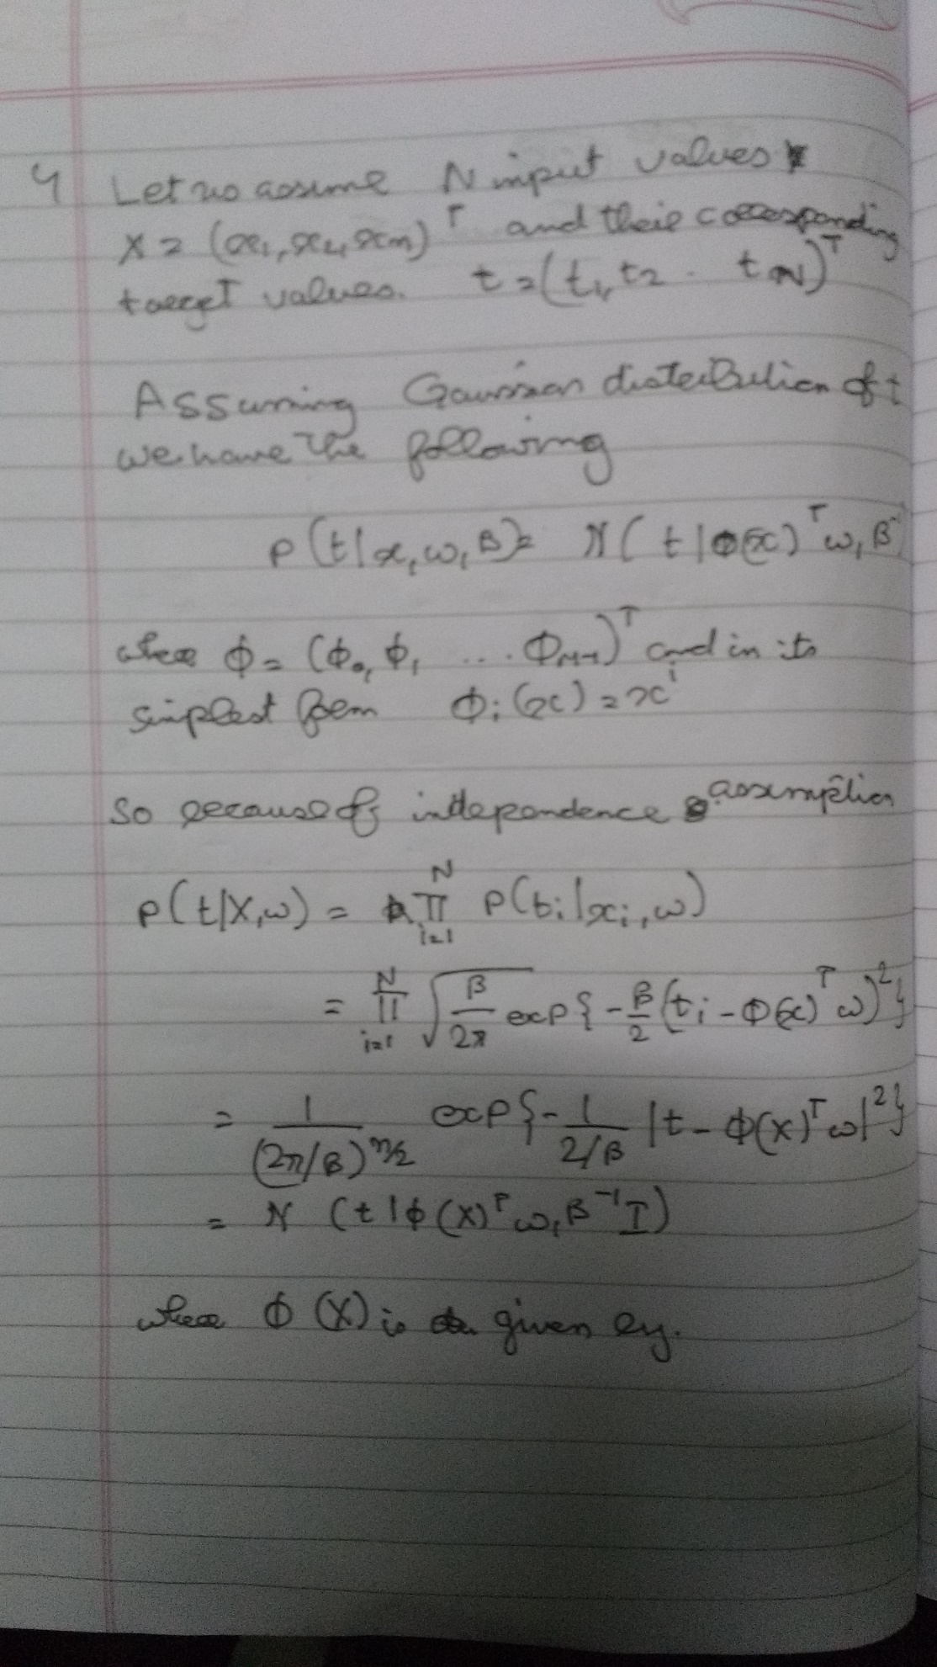  
   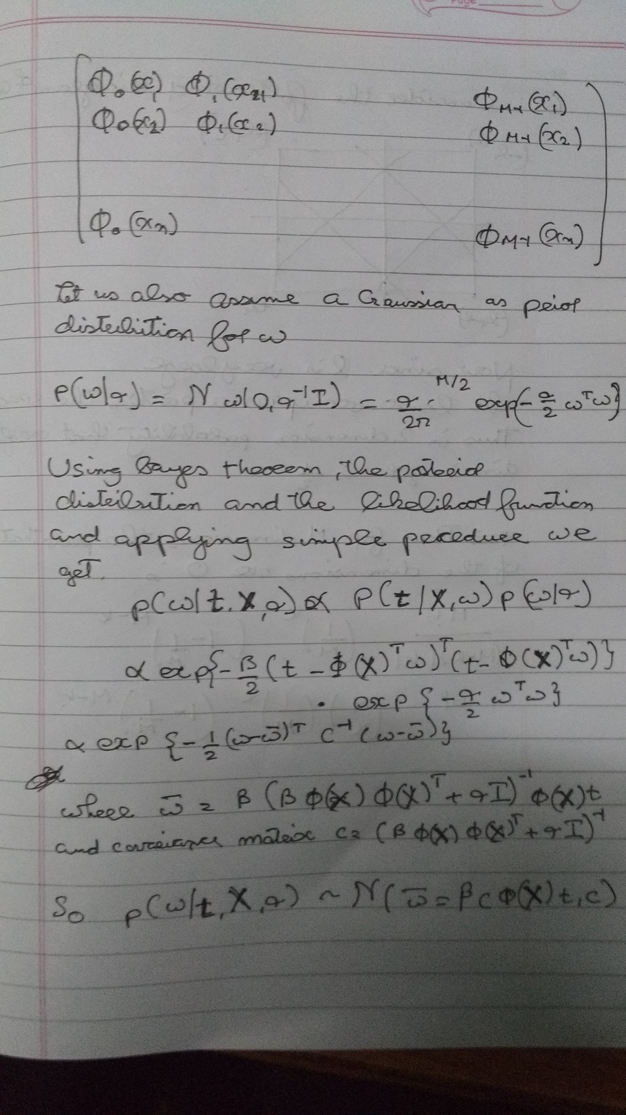
3. 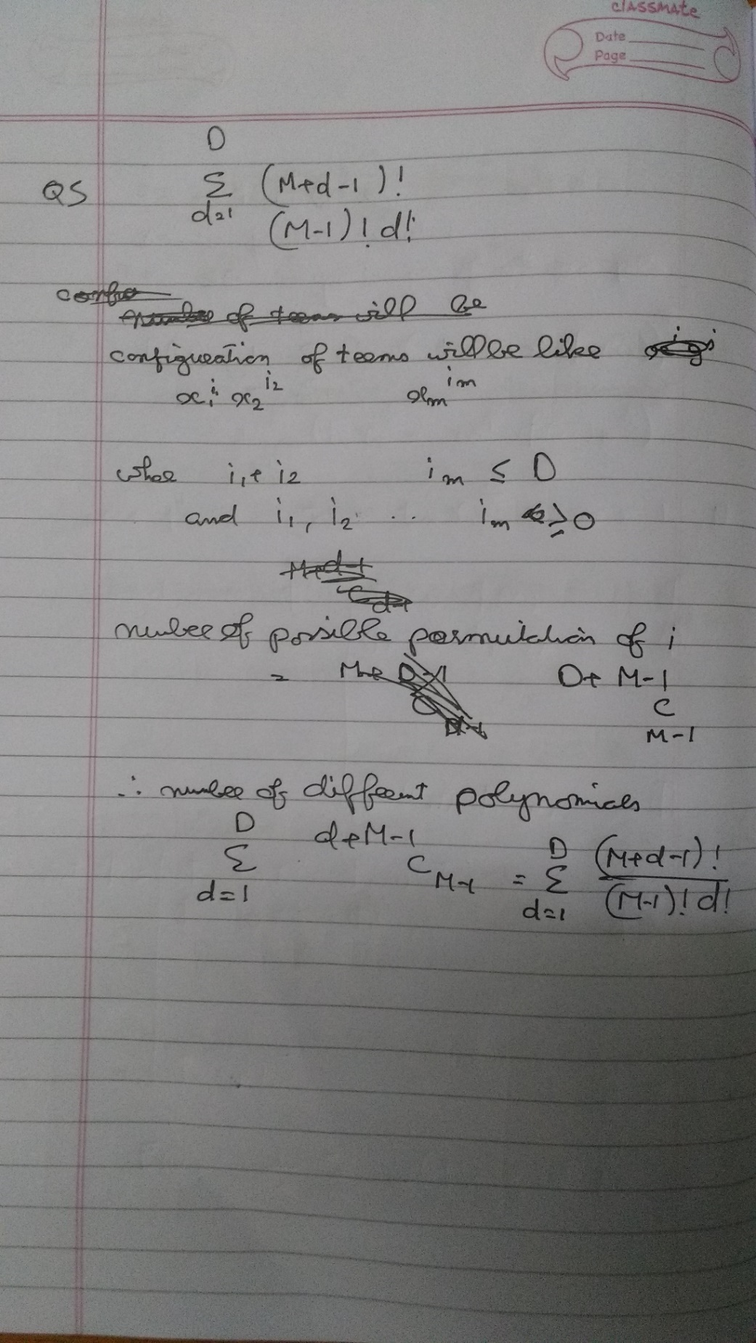
4. ..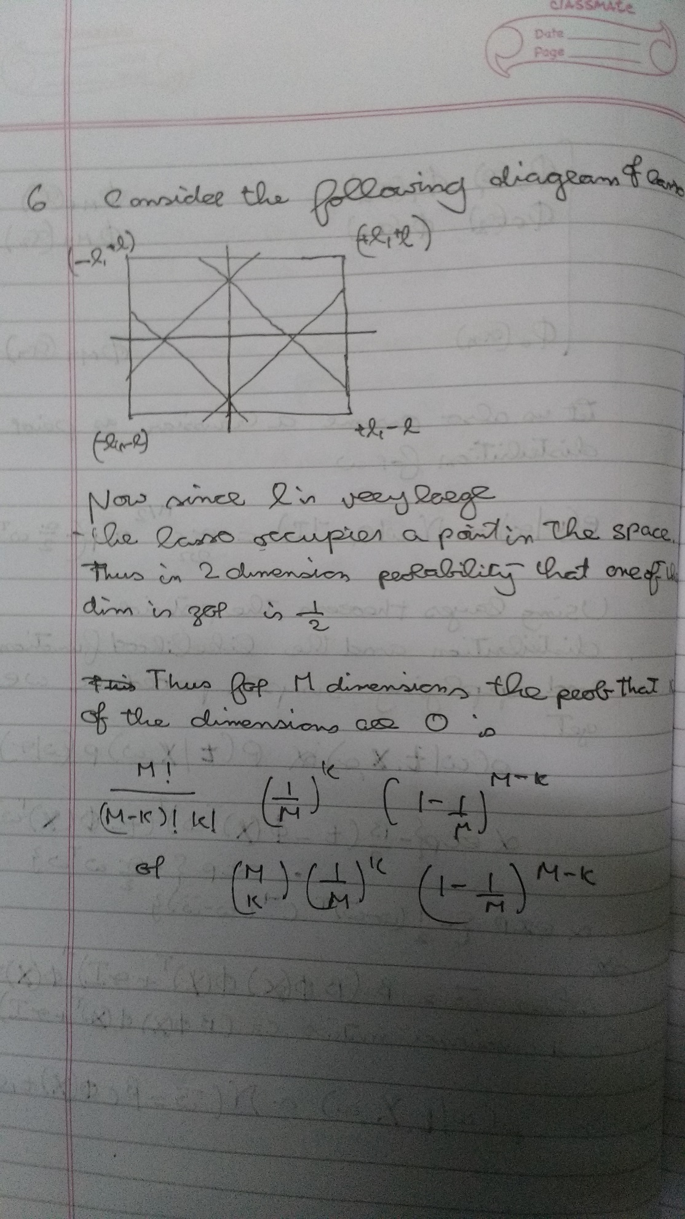

Instances: 63

Attributes: 10

x^1

x^2

x^3

x^4

x^5

x^6

x^7

x^8

x^9

class

Test mode:evaluate on training data

For a =

* 1. 0.1  
       
     𝜆 =
     1. 0.001

Linear Regression Model

class =

0.4953 * x^1 +

-0.0001 * x^9 +

-0.0207

Time taken to build model: 0.03 seconds

=== Evaluation on training set ===

=== Summary ===

Correlation coefficient 0.9222

Mean absolute error 0.236

Root mean squared error 0.2809

Relative absolute error 36.0293 %

Root relative squared error 38.6637 %

Total Number of Instances 63

* + 1. 0.01

Linear Regression Model

class =

0.4951 * x^1 +

-0.0001 * x^9 +

-0.0207

Time taken to build model: 0.01 seconds

=== Evaluation on training set ===

=== Summary ===

Correlation coefficient 0.9222

Mean absolute error 0.236

Root mean squared error 0.2809

Relative absolute error 36.0281 %

Root relative squared error 38.6637 %

Total Number of Instances 63

* + 1. 0.1

Linear Regression Model

class =

0.0896 * x^3 +

-0.0001 * x^9 +

-0.0226

Time taken to build model: 0.01 seconds

=== Evaluation on training set ===

=== Summary ===

Correlation coefficient 0.7091

Mean absolute error 0.441

Root mean squared error 0.5123

Relative absolute error 67.316 %

Root relative squared error 70.5198 %

Total Number of Instances 63

* + 1. 1

Linear Regression Model

class =

0.0011 * x^7 +

-0.0001 * x^9 +

-0.0107

Time taken to build model: 0.01 seconds

=== Evaluation on training set ===

=== Summary ===

Correlation coefficient 0.4225

Mean absolute error 0.5827

Root mean squared error 0.6703

Relative absolute error 88.9447 %

Root relative squared error 92.2722 %

Total Number of Instances 63

* + 1. 10

Linear Regression Model

class =

0.3873 * x^1 +

-0.001 * x^5 +

-0.0002 * x^7 +

0 * x^9 +

-0.0147

Time taken to build model: 0.01 seconds

=== Evaluation on training set ===

=== Summary ===

Correlation coefficient 0.9315

Mean absolute error 0.2571

Root mean squared error 0.3142

Relative absolute error 39.2476 %

Root relative squared error 43.2522 %

Total Number of Instances 63

* + 1. 100

Linear Regression Model

class =

0.1199 * x^1 +

-0.0087

Time taken to build model: 0.01 seconds

=== Evaluation on training set ===

=== Summary ===

Correlation coefficient 0.7842

Mean absolute error 0.5022

Root mean squared error 0.5717

Relative absolute error 76.6562 %

Root relative squared error 78.7014 %

Total Number of Instances 63

* + 1. 1000

Linear Regression Model

class =

0.0183 * x^1 +

-0.0129

Time taken to build model: 0.01 seconds

=== Evaluation on training set ===

=== Summary ===

Correlation coefficient 0.7842

Mean absolute error 0.6263

Root mean squared error 0.7006

Relative absolute error 95.6043 %

Root relative squared error 96.4519 %

Total Number of Instances 63

* 1. 0.5  
       
     𝜆 =
     1. 0.001

Linear Regression Model

class =

0.5151 * x^1 +

-0.0001 * x^9 +

-0.0995

Time taken to build model: 0.06 seconds

=== Evaluation on training set ===

=== Summary ===

Correlation coefficient 0.8016

Mean absolute error 0.4265

Root mean squared error 0.5302

Relative absolute error 55.5615 %

Root relative squared error 59.7835 %

Total Number of Instances 63

* + 1. 0.01

Linear Regression Model

class =

0.5149 * x^1 +

-0.0001 * x^9 +

-0.0995

Time taken to build model: 0.01 seconds

=== Evaluation on training set ===

=== Summary ===

Correlation coefficient 0.8016

Mean absolute error 0.4265

Root mean squared error 0.5302

Relative absolute error 55.5624 %

Root relative squared error 59.7835 %

Total Number of Instances 63

* + 1. 0.1

Linear Regression Model

class =

-0.0022 * x^6 +

0.0002 * x^8 +

0 * x^9 +

-0.0434

Time taken to build model: 0.01 seconds

=== Evaluation on training set ===

=== Summary ===

Correlation coefficient 0.24

Mean absolute error 0.7399

Root mean squared error 0.861

Relative absolute error 96.399 %

Root relative squared error 97.078 %

Total Number of Instances 63

* + 1. 1

Linear Regression Model

class =

0.7385 * x^1 +

-0.0675 * x^3 +

-0.0928

Time taken to build model: 0.01 seconds

=== Evaluation on training set ===

=== Summary ===

Correlation coefficient 0.8424

Mean absolute error 0.3923

Root mean squared error 0.4814

Relative absolute error 51.114 %

Root relative squared error 54.2743 %

Total Number of Instances 63

* + 1. 10

Linear Regression Model

class =

0.3749 * x^1 +

0 * x^9 +

-0.0932

Time taken to build model: 0.01 seconds

=== Evaluation on training set ===

=== Summary ===

Correlation coefficient 0.7914

Mean absolute error 0.4505

Root mean squared error 0.5631

Relative absolute error 58.6898 %

Root relative squared error 63.4884 %

Total Number of Instances 63

* + 1. 100

Linear Regression Model

class =

0.1333 * x^1 +

-0.0901

Time taken to build model: 0.01 seconds

=== Evaluation on training set ===

=== Summary ===

Correlation coefficient 0.7141

Mean absolute error 0.6022

Root mean squared error 0.7337

Relative absolute error 78.4577 %

Root relative squared error 82.7272 %

Total Number of Instances 63

* + 1. 1000

Linear Regression Model

class =

0.0203 * x^1 +

-0.0948

Time taken to build model: 0.04 seconds

=== Evaluation on training set ===

=== Summary ===

Correlation coefficient 0.7141

Mean absolute error 0.7367

Root mean squared error 0.8609

Relative absolute error 95.9842 %

Root relative squared error 97.0669 %

Total Number of Instances 63

* 1. 1  
       
     𝜆 =
     1. 0.001

Linear Regression Model

class =

0.695 * x^1 +

-0.0099 * x^5 +

-0.1009

Time taken to build model: 0.01 seconds

=== Evaluation on training set ===

=== Summary ===

Correlation coefficient 0.593

Mean absolute error 0.796

Root mean squared error 0.9924

Relative absolute error 81.5531 %

Root relative squared error 80.517 %

Total Number of Instances 63

* + 1. 0.01

Linear Regression Model

class =

0.6945 * x^1 +

-0.0099 * x^5 +

-0.1009

Time taken to build model: 0.02 seconds

=== Evaluation on training set ===

=== Summary ===

Correlation coefficient 0.593

Mean absolute error 0.796

Root mean squared error 0.9924

Relative absolute error 81.5492 %

Root relative squared error 80.517 %

Total Number of Instances 63

* + 1. 0.1

Linear Regression Model

class =

0.7037 * x^1 +

-0.0104 * x^5 +

0.0051 * x^6 +

-0.0006 * x^8 +

-0.1953

Time taken to build model: 0.01 seconds

=== Evaluation on training set ===

=== Summary ===

Correlation coefficient 0.6118

Mean absolute error 0.7922

Root mean squared error 0.9751

Relative absolute error 81.1621 %

Root relative squared error 79.1093 %

Total Number of Instances 63

* + 1. 1

Linear Regression Model

class =

0.8336 * x^1 +

-0.096 * x^3 +

-0.0941

Time taken to build model: 0.02 seconds

=== Evaluation on training set ===

=== Summary ===

Correlation coefficient 0.6052

Mean absolute error 0.7952

Root mean squared error 0.9851

Relative absolute error 81.4653 %

Root relative squared error 79.925 %

Total Number of Instances 63

* + 1. 10

Linear Regression Model

class =

0.3693 * x^1 +

-0.0001 * x^9 +

-0.0971

Time taken to build model: 0.01 seconds

=== Evaluation on training set ===

=== Summary ===

Correlation coefficient 0.5636

Mean absolute error 0.8103

Root mean squared error 1.0381

Relative absolute error 83.0203 %

Root relative squared error 84.2186 %

Total Number of Instances 63

* + 1. 100

Linear Regression Model

class =

0.1054 * x^1 +

-0.0848

Time taken to build model: 0.01 seconds

=== Evaluation on training set ===

=== Summary ===

Correlation coefficient 0.4061

Mean absolute error 0.9156

Root mean squared error 1.168

Relative absolute error 93.8028 %

Root relative squared error 94.7577 %

Total Number of Instances 63

* + 1. 1000

Linear Regression Model

class =

+

-0.0892

Time taken to build model: 0.01 seconds

=== Evaluation on training set ===

=== Summary ===

Correlation coefficient 0

Mean absolute error 0.9761

Root mean squared error 1.2326

Relative absolute error 100 %

Root relative squared error 100 %

Total Number of Instances 63

* 1. 2  
       
     𝜆 =
     1. 0.001

Linear Regression Model

class =

0.9374 * x^1 +

-0.1023 * x^3 +

0.0731

Time taken to build model: 0.03 seconds

=== Evaluation on training set ===

=== Summary ===

Correlation coefficient 0.3342

Mean absolute error 1.7087

Root mean squared error 2.1675

Relative absolute error 93.4849 %

Root relative squared error 94.2496 %

Total Number of Instances 63

* + 1. 0.01

Linear Regression Model

class =

0.936 * x^1 +

-0.1021 * x^3 +

0.0731

Time taken to build model: 0.01 seconds

=== Evaluation on training set ===

=== Summary ===

Correlation coefficient 0.3342

Mean absolute error 1.7086

Root mean squared error 2.1675

Relative absolute error 93.4841 %

Root relative squared error 94.2496 %

Total Number of Instances 63

* + 1. 0.1

Linear Regression Model

class =

0.9222 * x^1 +

-0.1 * x^3 +

0.0734

Time taken to build model: 0.01 seconds

=== Evaluation on training set ===

=== Summary ===

Correlation coefficient 0.3342

Mean absolute error 1.7088

Root mean squared error 2.1675

Relative absolute error 93.495 %

Root relative squared error 94.2509 %

Total Number of Instances 63

* + 1. 1

Linear Regression Model

class =

0.8069 * x^1 +

-0.0825 * x^3 +

0.0758

Time taken to build model: 0.02 seconds

=== Evaluation on training set ===

=== Summary ===

Correlation coefficient 0.3331

Mean absolute error 1.7112

Root mean squared error 2.1696

Relative absolute error 93.6228 %

Root relative squared error 94.3428 %

Total Number of Instances 63

* + 1. 10

Linear Regression Model

class =

0.2828 * x^1 +

0.0881

Time taken to build model: 0.01 seconds

=== Evaluation on training set ===

=== Summary ===

Correlation coefficient 0.2596

Mean absolute error 1.7492

Root mean squared error 2.2224

Relative absolute error 95.7019 %

Root relative squared error 96.6379 %

Total Number of Instances 63

* + 1. 100

Linear Regression Model

class =

0.1257 * x^1 +

0.0815

Time taken to build model: 0.01 seconds

=== Evaluation on training set ===

=== Summary ===

Correlation coefficient 0.2596

Mean absolute error 1.7793

Root mean squared error 2.2513

Relative absolute error 97.3491 %

Root relative squared error 97.8915 %

Total Number of Instances 63

* + 1. 1000

Linear Regression Model

class =

+

0.0763

Time taken to build model: 0.01 seconds

=== Evaluation on training set ===

=== Summary ===

Correlation coefficient 0

Mean absolute error 1.8277

Root mean squared error 2.2997

Relative absolute error 100 %

Root relative squared error 100 %

Total Number of Instances 63

* 1. 10  
       
     𝜆 =
     1. 0.001

class =

-4.6864 * x^2 +

0.4606 * x^4 +

5.7743

Time taken to build model: 0.02 seconds

=== Evaluation on training set ===

=== Summary ===

Correlation coefficient 0.3906

Mean absolute error 8.0141

Root mean squared error 9.7644

Relative absolute error 92.2647 %

Root relative squared error 92.0566 %

Total Number of Instances 63

* + 1. 0.01

Linear Regression Model

class =

-4.6712 * x^2 +

0.4589 * x^4 +

5.7577

Time taken to build model: 0.08 seconds

=== Evaluation on training set ===

=== Summary ===

Correlation coefficient 0.3906

Mean absolute error 8.0138

Root mean squared error 9.7644

Relative absolute error 92.2619 %

Root relative squared error 92.0567 %

Total Number of Instances 63

* + 1. 0.1

Linear Regression Model

class =

-4.5249 * x^2 +

0.4425 * x^4 +

5.5971

Time taken to build model: 0.01 seconds

=== Evaluation on training set ===

=== Summary ===

Correlation coefficient 0.3905

Mean absolute error 8.0115

Root mean squared error 9.7654

Relative absolute error 92.235 %

Root relative squared error 92.066 %

Total Number of Instances 63

* + 1. 1

Linear Regression Model

class =

3.7124 * x^1 +

-2.7438 * x^2 +

-0.7805 * x^3 +

0.0289 * x^6 +

0.0005 * x^9 +

4.402

Time taken to build model: 0.01 seconds

=== Evaluation on training set ===

=== Summary ===

Correlation coefficient 0.483

Mean absolute error 7.8584

Root mean squared error 9.3402

Relative absolute error 90.4723 %

Root relative squared error 88.0579 %

Total Number of Instances 63

* + 1. 10

Linear Regression Model

class =

-1.3356 * x^2 +

0.0013 * x^8 +

2.3379

Time taken to build model: 0.01 seconds

=== Evaluation on training set ===

=== Summary ===

Correlation coefficient 0.3696

Mean absolute error 8.1603

Root mean squared error 10.0002

Relative absolute error 93.948 %

Root relative squared error 94.2794 %

Total Number of Instances 63

* + 1. 100

Linear Regression Model

class =

+

-0.6515

Time taken to build model: 0.02 seconds

=== Evaluation on training set ===

=== Summary ===

Correlation coefficient 0

Mean absolute error 8.6859

Root mean squared error 10.6069

Relative absolute error 100 %

Root relative squared error 100 %

Total Number of Instances 63

* + 1. 1000

Linear Regression Model

class =

+

-0.6515

Time taken to build model: 0.01 seconds

=== Evaluation on training set ===

=== Summary ===

Correlation coefficient 0

Mean absolute error 8.6859

Root mean squared error 10.6069

Relative absolute error 100 %

Root relative squared error 100 %

Total Number of Instances 63

8)

Bias of mean estimator =

Where M is mean ie 5 here and mi is mean of ith  subset

Variance of mean estimator =

Where vi = is variance of ith  subset

Bias of variance estimator = - V

Where xi  = ith term and V is variance ie 2 and X is mean of all xi

Variance of variance estimator = is the variance of all the 100 variances of the subset

Bias of mean estimator

-0.0542

Variance of mean estimator

0.3891

Bias of variance estimator

1.7724

Variance of variance estimator

2.8490